UTC2720: Report on Income Inequality and Fairness in countries

Cheong Jia Sheng (E0324336), Jiang Qiwei (E0031959), Liu Chun Xi (E0326088)

This report discusses the trends in income inequality in five countries: Singapore, Malaysia, Norway, USA and Switzerland.The income shares for the top 1%, next 9% and bottom 90% for the past four decades are plotted, along with another graph which shows how much the income shares of each strata differs from the theoretical ideal, obtained by fitting a lognormal distribution to the income distribution data of each country. Some explanations are also put forward as to why the trends are as such.

**Singapore**

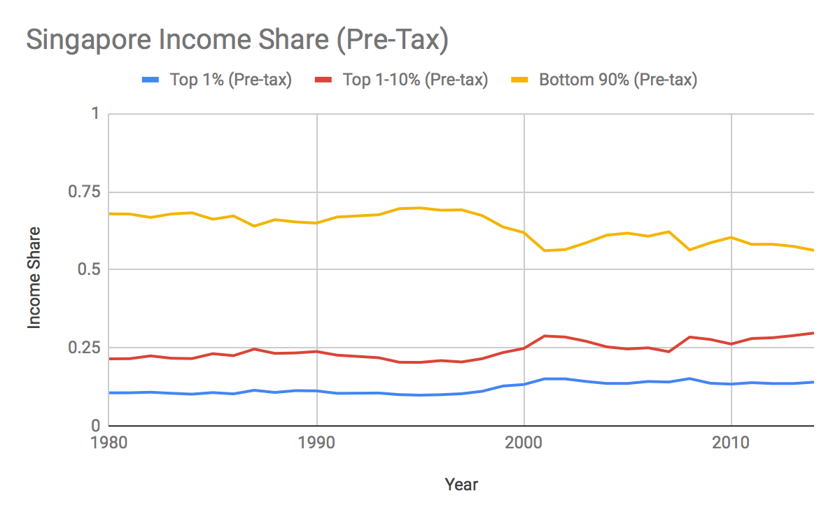

**Figure 1: Income share in Singapore (pre-tax)**

In Singapore, the extent of income inequality could be seen to have grown over the years. While the income shares of all 3 groups held steady from 1980 to 2000, a sudden change in income shares took place around 2000, with the bottom 90% falling from around 70% of the total share to close to 60%, mirrored by an equal increase in the income shares of the top 10%. Singapore today is among the more unequal countries in the world. This is the result of several trends during the period.

*Technological change*

In the early years of Singapore’s independence (1960-70s), the country’s development strategy focused on labor-intensive export-oriented industries, such as textiles and electronics, which employed large numbers of low- or semi-skilled labor, and the country enjoyed high growth as well as low inequality during the period. However, beginning in the 1980s, the structure of the global economy gradually shifted to emphasise knowledge-intensive industries such as value-added manufacturing and services, and Singapore responded by investing heavily in upgrading the skills of workers and helping industries restructure. Coupled with increasing globalisation in the same period which enabled increased trade and larger markets, highly skilled workers as well as highly efficient industries benefited immensely from the opportunities these brought about. On the other hand, less skilled workers who found it hard to adjust to the changing demands of the economy were unable to take advantage of the changes and were faced with lower wages or even structural unemployment. Considering that Singapore is a small economy highly vulnerable and responsive to world trends, inequality caused by the skills and knowledge divide is more pronounced in Singapore than elsewhere.

*Immigration policies*

Until very recently, Singapore has adopted a relatively relaxed immigration policy, aimed at attracting in particular highly skilled workers from around the region to bring their expertise to the country. Singapore furthermore has a very business-friendly environment compared to other countries in the region, encouraging many multinational companies to either be headquartered or set up branches in Singapore, bringing with them technological know-how as well as talented managers. These immigrants and expats are usually paid an amount comparable to the remuneration they would have received back home, hence this increased the numbers of those at the high end of its income distribution. On the other end of the spectrum, Singapore also relies heavily on foreign workers for low-skilled work in various industries, often shunned by locals, such as construction and domestic work. Even as these workers are paid much more than what is possible back home, their pay is still significantly lower than that of an average Singaporean, thus this contributed to a decrease in the bottom income share as well.

*Education system*

Singapore’s education system pursues a policy of “streaming” students based on ability from an early age and throughout their educational career, and is biased towards favoring the high-performing students. From an early age, the brightest few percent of the cohort are selected into state-provided special programs such as Gifted and Integrated Programmes (for primary and secondary students respectively) where they gain access to high-quality teaching and education resources to further develop themselves, as well as company with like-minded peers. Many of the elite in Singapore society disproportionately come from such education backgrounds. There are similarly “streams” of students for other ability levels, such as Express, Normal Academic and Normal Technical in secondary school. These students then go down very different paths, with the more academically capable going to Junior Colleges and Polytechnics, and most eventually entering university, while those who performed less well academically end up in Institutes of Technical Education, which provides mostly vocational training and often seen in society as “dumping grounds” for those left behind. While such a policy presumably achieves its goal of making the most of the potential of bright young minds in service of the nation, high levels of inequality is created and reinforced as those who fell behind early might find it much harder to catch up later on, while those identified as “talents” early have to resources to move further ahead. Moreover, such inequality is often self-perpetuating: given the high emphasis placed on education credentials in Singapore, well-off parents often spend large sums in their children’s academic development, through private tuition or enrichment classes, something which less well-off parents often find financially challenging to provide for their own children.

*Near-absent minimum wage*

Singapore has always resisted implementing a nation-wide minimum wage policy, believing that it would lead to unemployment for the less-skilled workers (especially with more widespread automation), as well as negatively impact the efficiency and competitiveness of companies in Singapore. Instead, the state opted for alternative policies such as income support, employment assistance and skills retraining for those near the bottom of the income distribution to ensure overall full employment and high competitiveness.

There are mandated minimum wages, according to the Progressive Wage Model, for only a few jobs, such as cleaners, gardeners and security guards; even then, they are set at very low levels of about $1000 per month ($2000 is often estimated to be the minimum cost of living in Singapore) and have barely kept up with inflation. The Progressive Wage Model was only brought into place after the issue of severe undercompensation in the above industry were continually brought up.

***Comparison with ideal***

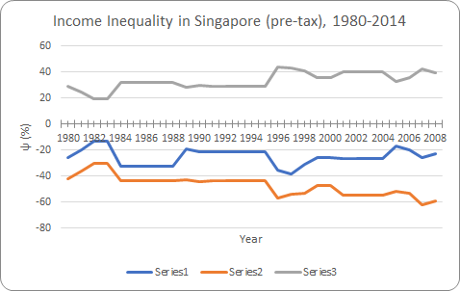

**Figure 2: Income Inequality Coefficient of Singapore (pre-tax)**

Series 1, 2 and 3 shows how much the incomes of the top 1%, next 9% and bottom 90% in Singapore, respectively, differs from the “ideals” obtained from fitting a lognormal distribution to the data, and how they changed over the years. As can be seen, the top 1% receives about 20-40% more income than the predicted “fair” share according to the model. This is partly due to the relatively large proportion of foreign expats and professionals (which skewed the distribution than if Singapore were a closed economy), though domestic policies which rewards the top may have played a role as well. The increasing trend may be attributed to intensifying globalisation in the past few decades, as well as perpetuation of inequality internally due to factors such as the educational divide, though tightening restrictions on immigration in recent years may have slightly ameliorated the rise in inequality. The remaining 99% have (mostly) received a share of income lower than the “fair” share, with the 90-99th percentiles receiving on average 20% less (with a stable trend), while the bottom 90% income fell from about 60% to only 40% of the share which the model predicts. This too can be partly be explained by the fact that since Singapore is only a small economy in a highly globalised world, its labor market is only a truncated segment of the world labor market, and therefore has a skewed distribution of employment and income. (In other words, the lognormal distribution may not produce an appropriate fit in Singapore’s situation, as the “fair” pay for many jobs depend on their equivalents in other countries with very different incomes, rather than determined internally.) Other explanatory factors include the lack of a minimum wage (assumed by the model) for most jobs, which depressed wages at the bottom, as well as increasing competition which pushes down wages for lower-skill jobs resulting from globalisation and immigration.

**Malaysia**

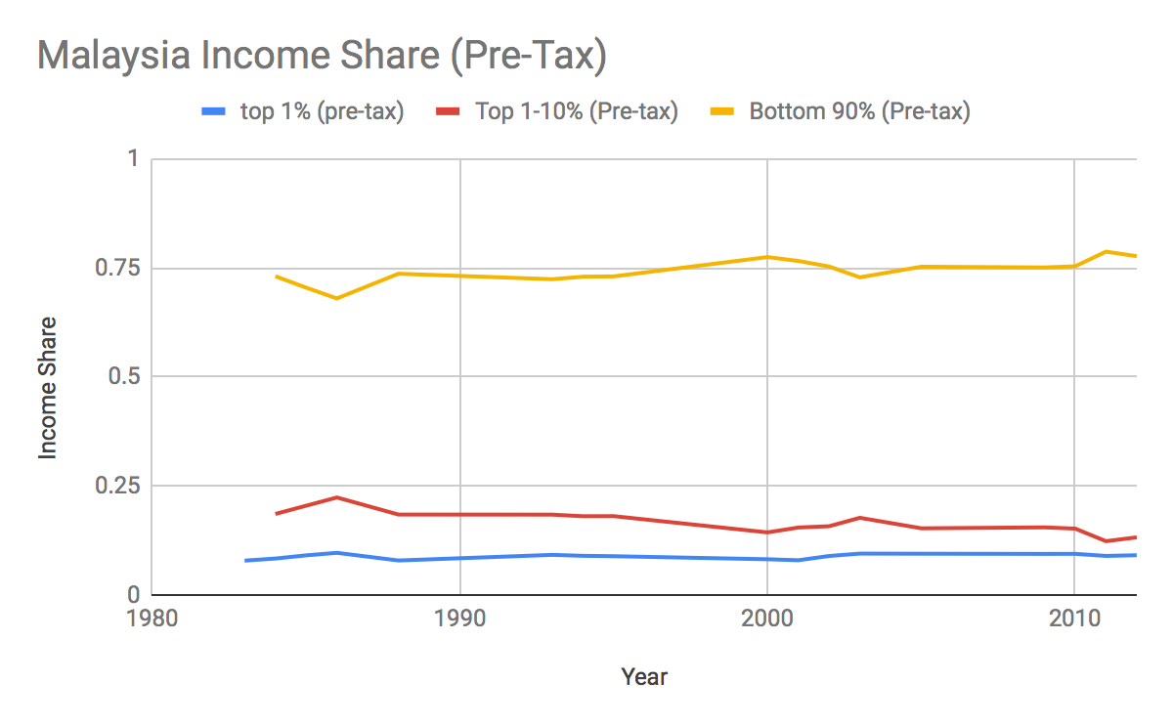

**Figure 3: Income share in Malaysia (pre-tax)**

In Malaysia, the income shares of the various strata of society has remained mostly stable over the years. The top 1%, next 9% and bottom 90% receives about 10%, 15% and 75% of the country’s total income, respectively. The country has a fairly equal distribution of income for the masses, but at the same time extreme wealth for the few at the top, which we can see in the income inequality distribution graph below.

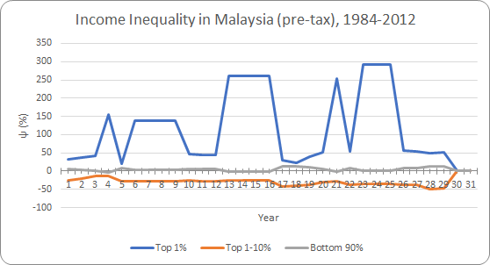

**Figure 4: Income Inequality Coefficient of Malaysia (pre-tax)**

Figure 4 compares the actual income shares of the various strata in Malaysia with the fitted lognormal “ideal” shows an interesting trend. The top 1% is making up to several times their fair share according to the model, the next 9% is (on average) making *less* than their fitted fair share by about 25-50%, while the bottom 90% is making more or less their fair share of income as predicted.

The erratic fluctuations for the top 1% 's income inequality coefficient is likely a result of insufficient data for real income shares in Malaysia. Regardless, the swings does not affect the values for top 1-10% and bottom 90% significantly, due to the top 1% income being a relatively tiny proportion of Malaysian’s income.

Malaysia have a peculiar income inequality distribution that is different from other countries. Instead of a highly positive income inequality coefficient for the top 10%, we see an inverted graph in which the bottom 90% receives close to their fair share of income, the top 1-10% receives much less than their fair share and the top 1% much more than their deserved share.

The bottom 90% is kept near 0% on the income inequality coefficient from 1970s onwards through the New Economic Policy, which made a highly coordinated effort on eradicating poverty in Malaysia. The policy was deemed as a highly effective one, proving instrumental in a near completely removed hardcore poverty - the state of earning less than 50% of median income in the country. Inspection of the Gini coefficient has revealed a fall from 0.513 in 1970 to 0.399 in 2016, which was a rather massive shift. However, there are little changes from the graph above, suggesting that there is also a large shift in income inequality within the 3 income groups as a result of the policy. Regardless, the role of New Economic Policy in redistributing income and enhancing the income for the lower income groups was instrumental in keeping the income share of the bottom 90% close to a fair value.

However, the New Economic Policy also went under massive criticism regarding its fairness. The policy, while effective in result, stemmed from an intention that was biased in nature. The primary goal of the policy was to increase the wealth and income of the Bumiputras (majority race including Malays and aboriginals) in Malaysia, through favourable subsidy and taxation policy that transfer wealth and income from non-Bumiputras Malaysians and foreigners. The maintenance of income inequality at an equally fair level was just a by-product of Bumiputras forming most of the lower wealth and income groups in Malaysia at the introduction of the policy. The income inequality in Malaysia is thus not as fair as the graph shows.

In more recent years, a minimum salary has been introduced to act as a new approach to benefit lower income groups as opposed to the incumbent New Economic Policy.

The disparity between the top 1-10% income shares and ideal suggests that there is still a lack of higher-skilled workers in Malaysia that can make a higher income. This is in line with a recent Malaysian report 'State of household 2018', which identified that only 14.7% of employed Malaysians hold a graduate degree.

The top 1%, on the other hand, seems to be earning a disproportionately high income share, which does not follow the lognormal distribution in an ideal free market economy.

Both disparities of the top 1% and the top 1-10% suggests that they may be multiple classes of citizens in Malaysia, each following a different lognormal ideal income distribution. When assessed as a single class, this gives rise to an unusual income inequality coefficient graph that identifies deviation while not representative of extreme income inequality.

**Norway**

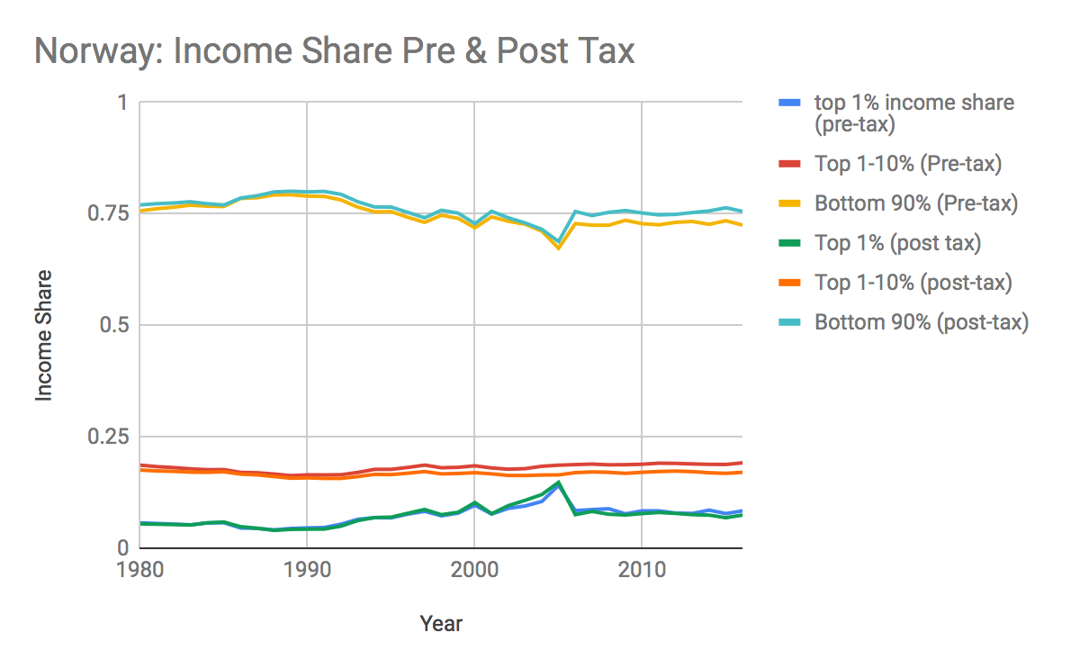

**Figure 5: Income share in Norway (pre-tax and post-tax)**

A cursory glance at Figure 5 tells that Norway seems to possess an economy with much less inequality than the other countries. The top 1% took around 5-7% of the income share, the top 1-10% around 20%, and the remaining 75% given to the bottom 90%. The income shares have remained stable over the past 40 years.

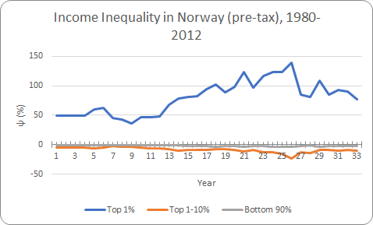

**Figure 6: Income Inequality Coefficient of Norway (pre-tax)**

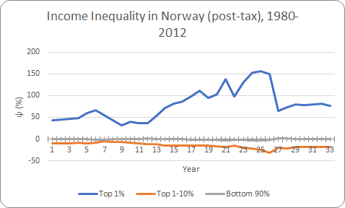

**Figure 7: Income Inequality Coefficient of Norway (post-tax)**

An inspection of figures 6 and 7 for Norway shown a relatively low impact of taxation on income inequality. More importantly, both graphs show a striking similarity between the income shares of the bottom 99% of the population and the fair income share in an ideal free market aka. Bhuvai. The ineffectiveness of taxation on our calculated income inequality coefficient values is surprising, and the cause can be attributed to incongruence in the data we collected of the minimum and maximum salary for Norway.

The adherence of the bottom 99% to the ideal income distribution is one of remarkable significance, as it shows that Norway, without knowledge of the actual ideal free market income distribution, has been able to mimic it. More remarkably, the above income distribution is reproduced in an economy with significant government intervention, as opposed to in an uninterrupted free market aligned with the Nozickian theory of distributive justice.

The income distribution in Norway is regulated by multiple approaches in an extent rarely seen in other countries. Progressive taxation, the taxation of higher income group over others, is practiced in most states. However, in Norway, the tax rates are significantly higher than other countries, in order to channel excessive income from the top percentiles in order to enhance the welfare of the people as a whole.

Union membership is also much more prevalent in Norway, with over half its citizens in unions as opposed to around a quarter in the US and UK. Unions serve as a mediator between the government, corporations and employees, enabling the employees to fight for and achieve competitive working terms. Around 70% of Norwegians have union agreements inclusive of wage floors as a result.

However, we still note a deviation from ideal income distribution in Norway, as the top 1% seems to be earning around 100-150% more than their fair share of income. The same reasoning applied for Malaysia may be adopted here: the Norwegian society likely follows a two-class society structure, such that there are two lognormal distributions of citizens enjoying two different levels of net utility. While this is not a utopian income distribution as you would achieve in BhuVai, Norway is as close as a society with fair income inequality as you may find in real life markets.

**USA**

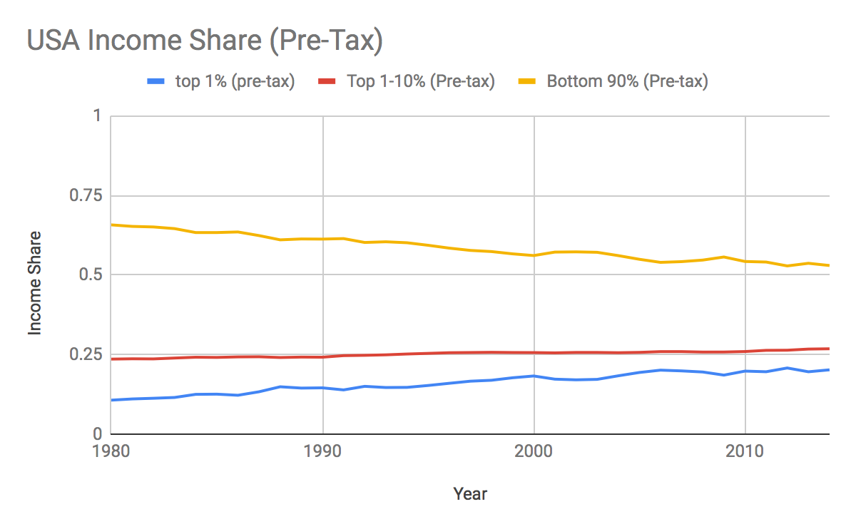

**Figure 8: Income share in USA (pre-tax)**

As can be seen from the chart, income inequality has been widening in the USA over the last 4 decades. In 1980, the income share of the bottom 90% of the population was about 65%, which is already much lower as compared to many other Western countries such as Norway and Switzerland. However, the situation just worsened over the years, with only about 52% left in 2014. In contrast, the income share of the top 1% has been rising steadily, approaching around 20% in recent years.

Factors such as technological changes, globalisation and declining unionisation could have all contributed to the widening income gap between the rich and the poor.

For instance, globalisation and technological changes boosted economics of scale, creating winner-take-all markets. A case in point can be seen in the rise of large multinational firms like Wal-Mart. Digitalisation and technological advancements in communications and transport allowed Wal-Mart to better manage their resources and to maintain large-scale supply and distribution networks in many countries around the world. Being a low-cost producer due to its large size and highly efficient operations, large firms like Wal-mart have often driven out competitors and as the dominant firm, have significant market power to dictate prices to suppliers, buyers and employees alike. This is partly responsible for the extremely high incomes of those at the top, who often own significant shares of such companies.

The US is also the hotbed for the births and rise of highly successful technology companies, such as Apple and Facebook, which also benefitted from recent advancements in computer and internet technology which allowed them to reach millions of users with innovative products. Owners of these technology firms, as well as employees with valuable skills and contributions that ensured the companies’ success, are very well rewarded when their companies have the opportunity to succeed.

On the other hand, rapid advances in technology has also left many jobs either obsolete or cheaper to be offshored to other countries with lower wages. This has occurred on a large scale for many manufacturing industries in the US, such as steel and automobiles. Many production processes are automated, requiring much fewer or no workers at all. Furthermore, lowered transportation costs and improved communications enabled many of the parts to be produced and assembled elsewhere in different parts of the world (as opposed to in one central location in the past), resulting in the loss of many previously well-paying manufacturing jobs in the US (sometimes causing severe recessions in cities where manufacturing was dominant, such as Detroit). The displaced workers are also often older and less able to retrain to take up other lucrative jobs, often facing instead a permanent decline in their income.

The restructuring of the US economy has the additional effect of causing a decline in union membership. As firms in the past were mostly in manufacturing and were hence typically large hire many employees over the long term, workers could organise themselves into unions to bargain with their firms’ management for better pay and benefits. However, today, the dominant firms in the US are mostly service firms which are smaller and often employs on a part-time or contract basis. Workers thus find it much harder to benefit from the bargaining power of a union and consequently receive lower compensation.

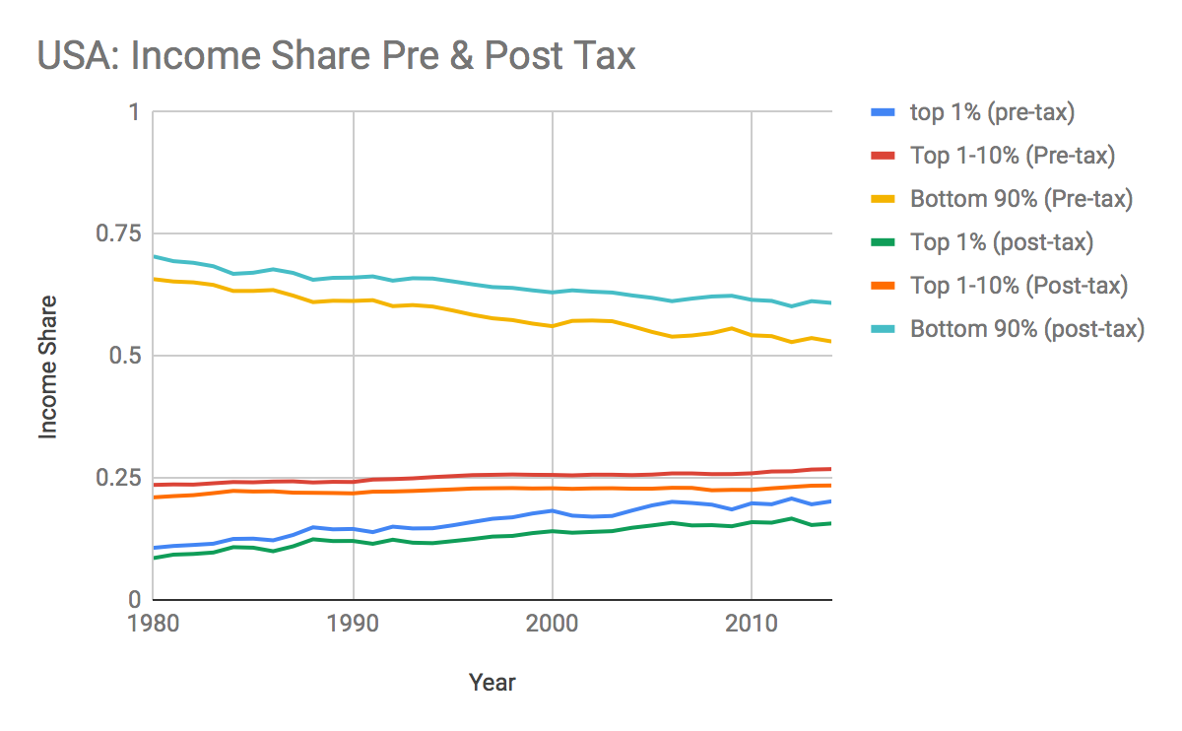

**Figure 9: Income share in USA (pre-tax and post-tax)**

The tax policies of the US is largely progressive, with the rich taxed proportionately more than the poor (and with the very poor or otherwise disadvantaged receiving transfer payments). Hence after tax and transfers, the bottom 90% see a modest increase in their income shares (to about 60% currently) while the top 10% saw a slight decline. There seems to also be a slight improvement in the progressiveness of the US tax policy in recent decades, seen from the increasing gap in pre- and post-tax income shares of each group since the 1990s. During that period, there was an increase in the tax rate from 36% to 39.6%, as well as an expansion of the social security system.

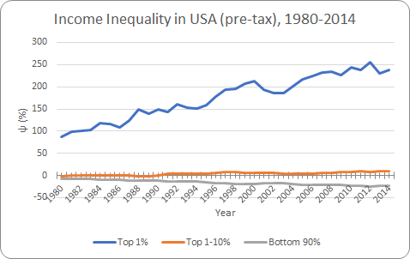

**Figure 10: Income Inequality Coefficient in USA (pre-tax)**

The chart shows that while the top 1-10% in the US roughly their “fair” share (as predicted by its fitted log-normal income share), the top 1% is earning about twice to thrice that of their predicted fair share, furthermore with a decidedly upward trend. Meanwhile, as income growth for the bottom 90% failed to keep up with the country’s overall average, their share of national income went from being nearly at the fair share in 1980 to about 25% short of it in 2014.

Such noticeable “unfairness” in the country’s income distribution is unlikely to be due to market forces alone. While the extreme riches of some at the top could be genuinely due to exceptional talent and hard work, combined with the rich opportunities available from being in the US (examples such as Warren Buffett or Steve Jobs come to mind), many have also grown resentful of the high levels of executive compensation (for a CEO it is about 350 times that of the salary of an average worker), believing it to be the result of an imperfect corporate governance system, where CEOs sit on one another’s boards and “scratch each other’s back” by mutually recommending high compensations, and where boards are often not easily held accountable to investors or other stakeholders in the company.

Meanwhile, the decreasing and less-than-fair income share of the bottom 90% can also be attributed to the fact that workers have less bargaining power than before and are losing representation in their companies, and thus have seen their incomes stagnate instead of benefiting from the country’s economic growth. Large numbers of displaced and/or otherwise under-employed workers, as well as laws that afford relatively fewer rights and security to workers are contributors to the trend as well.

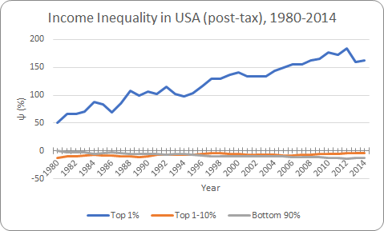

**Figure 11: Income Inequality Coefficient of USA (post-tax)**

Figure 11 shows that even after taxes and transfers, the top 1% barely see a decrease in their income shares and are still earning well above their predicted fair share. The reason why taxes had a rather small impact could be that they had large incomes to begin with, and furthermore much of it is in the form of passive income such as interest or capital gains which are less subjected to taxation. The impacts of taxation are thus mostly seen in the top 1-10% and the bottom 90%. From the graph both groups are making slightly less than their predicted fair share after tax and transfers, showing that income redistribution occurs from the top 1-10% to the bottom 90% as a result of the US tax policy.

**Switzerland**

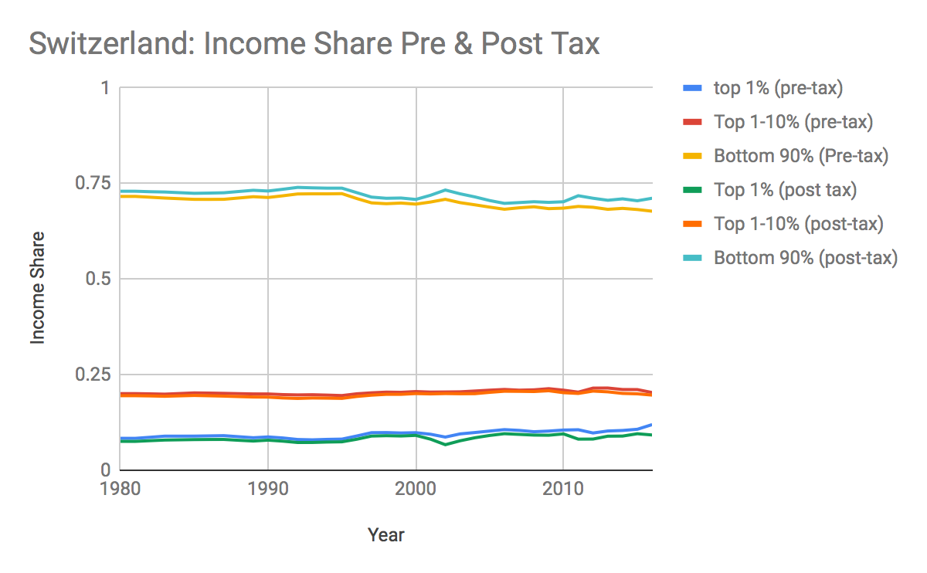

**Figure 12: Income share in Switzerland (pre-tax and post-tax)**

A quick analysis of Switzerland’s income share in Figure 12 suggests a great deal of similarity with Norway, albeit with slightly more inequality. The bottom 90% holds slightly less than 75% of the income, the top 1% around 7-8% and the top 1-10% around 20% of total income. The income distribution have remained largely stable over the years.

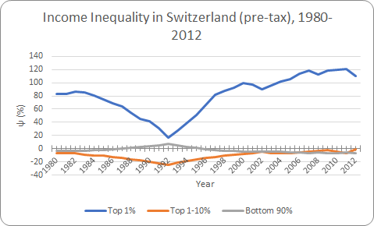

**Figure 13: Income Inequality Coefficient of Switzerland (pre-tax)**

Figure 13 shows how the incomes shares of each group compare with their theoretical ideals. The income share of the top 1% is about 50-100% more than the fitted “fair” share. This could be due to a high wealth ownership in Switzerland, as many of the richest in the world choose to park their assets in Switzerland as for foreign investors it is a well-known tax haven and furthermore there is secrecy and relatively few regulatory hurdles. Another reason could be that Switzerland is a major exporter to luxury goods (such as watches) which also enabled very high incomes for those in such industries. However, for the remaining 99%, their income shares are for the most part near the “ideal” fair share, hence showing that the country has a well-functioning free market not subject to significant distortions.

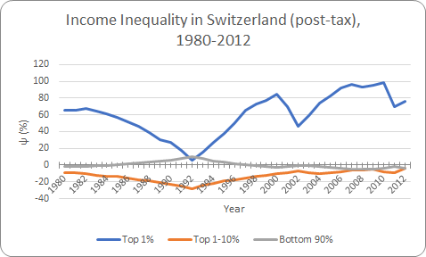

**Figure 14: Income Inequality Coefficient of Switzerland (post-tax)**

Figure 14 shows the income inequality coefficient for the various groups after tax. Minor effects can be seen for the bottom 99%, with their inequality inefficient coefficients moving slightly closer to the ideal 0%. The effect is a bit more pronounced for the top 1%, as the coefficient decreased by about 20%. Taxes are relatively low in Switzerland compared to many other European countries, with the maximum rate at 11.5%, hence the limited effect.

**Conclusion**

As the report shows, the level and nature of income inequality and/or fairness can differ significantly across countries depending on the specific characteristics of their economic and political systems as well as how these interact with the external environment. Technological changes and globalisation are among the factors in many countries that can produce or threaten to exacerbate existing inequalities. However, countries such as Malaysia and Norway show that appropriate tax and other policies can reduce inequality and improve fairness. Furthermore, this need not come at the cost of economic efficiency or dynamism as many of the fairest countries have also well-functioning free markets. Meanwhile, this report also shows how in fact unfair practices and distortions are often what leads to greater-than-ideal inequality, and should be reduced or curbed through political processes to ensure a free and fair market.